**ALCOHOL DETECTION:**

**ABSTRACT:**

Alcohol detection plays a crucial role in enhancing safety across various domains, including automotive, law enforcement, workplace management, and public health. This abstract provides an overview of advanced alcohol detection technologies designed to mitigate the risks associated with alcohol-impaired individuals.

In recent years, significant strides have been made in the development of alcohol detection systems. Traditional methods, such as breathalyzers, have been complemented and, in some cases, replaced by more sophisticated technologies. These advancements aim to enhance accuracy, efficiency, and user-friendliness. In this system we introduces the finerprint sensor to avoid the bike theft and it enhance the level of alcohol with messaging system.

**INTRODUCTION :**

Alcohol consumption has long been an integral part of human culture and social gatherings. While moderate alcohol consumption can be enjoyed responsibly by many, the abuse of alcohol can lead to a myriad of adverse consequences, including impaired judgment, accidents, and compromised public safety. In response to these challenges, the development of advanced alcohol detection technologies has gained prominence in various sectors, from road safety and law enforcement to workplace management and healthcare.

The significance of alcohol detection technologies lies in their potential to safeguard lives and promote responsible alcohol use. The consequences of alcohol impairment are far-reaching, with alcohol-related accidents, injuries, and fatalities occurring in various contexts. Drunk driving, for instance, remains a persistent threat on roads worldwide, contributing to countless casualties and property damage. Beyond the roads, alcohol impairment poses risks in workplaces, where it can compromise safety, productivity, and overall well-being.

Traditionally, alcohol detection relied on methods such as breathalyzers, which have proven effective but come with limitations. These devices, while valuable, have given rise to the need for more advanced, accurate, and non-invasive solutions that can address the shortcomings of traditional alcohol testing.

The evolution of alcohol detection technologies is now driven by a convergence of factors, including advancements in sensor technology, artificial intelligence, and an increasing emphasis on proactive safety measures. These innovations aim to enhance the accuracy, efficiency, and user-friendliness of alcohol detection systems. Moreover, they seek to reduce the intrusiveness and stigma associated with traditional testing methods.

**BLOCK DIAGRAM :**

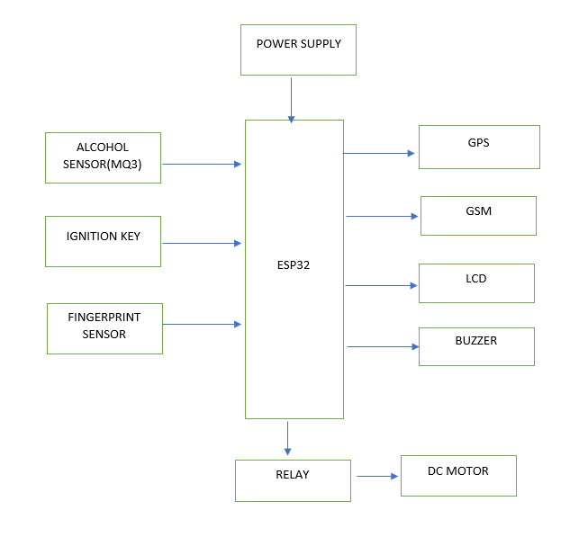

**PROPOSED SYSTEM:**

In this system we are using the esp32,ignition key, fingerprint sensor, relay, gps, gsm, lcd, buzzer, and dc motor . Once we on the ignition key, the fingerprint sensor will recognize the finger print if finger print will matched the alcohol value will be sensed if the value is below the threshold value relay will ON and DC motor ON otherwise the relay dosen’t on and the buzzer will be on then the sms alert will sent to the concern person with the gps location. . Also If fingerprint does not recognize the SMS alert will be sent to the concern person .

**HARDWARE REQUIRMENTS:**

* Ignition key
* Fingerprint sensor
* Mq3 sensor
* Relay
* Dc motor
* Gps
* Gsm
* Buzzer
* Esp32

**SOFTWARE REQUIRMENTS:**

* Arduino ide
* Embedded C

**HARDWARE DISCRIPTION:**

**ESP32**

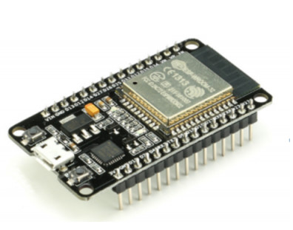

ESP32 is a low-powered, low-cost microcontroller (MCU) board, with both Wi-Fi and Bluetooth built in, and is based on a dual-core processor mechanism. The first one is a powerful processor, such as a Xtensa LX6 (~240 MHz) with 512 KiB memory and the second an ultra-low coprocessor (ULP) with only 8 KiB memory designed to run when ESP32 is in deep-sleep mode.

Other components include around 48 I/O pins (variable); an array of peripheral interfaces including temperature, hall effect, and capacitive touch sensors; and an 8-centimeter LCD panel, prominently visible here in an ESP32-WROVER board by Espressif Systems..

**Features:-**

* ESP32 has built-in integration of both WiFi and Bluetooth dual-mode.
* ESP32 has 34 programmable GPIOs present on the chip.
* ADC is of 12-bit SAR and can support up to 18 channels.
* DAC is 8-bit and it has 2 DAC channels.
* ESP32 also has 10 touch sensors embedded in it.
* ESP32 also has a Hall sensor in it.
* It supports 4 SPI channels.
* It also has 2 I²S channels.
* ESP32 has 2 I²C ports in it.
* It supports 3 UART channels.
* It also has 1 host(SD/eMMC/SDIO) and 1 slave(SDIO/SPI).
* ESP32 also supports the Ethernet MAC interface with dedicated DMA and IEEE 1588 support.
* It supports Two-Wire Automotive Interface (TWAI®, compatible with ISO11898-1)
* IR (TX/RX)
* Motor PWM
* LED PWM up to 16 channels

### ESP32 WiFi Key Features

* Wireless Networking Standard:**802.11 b/g/n**
* Wireless Standard: **802.11 n (2.4 GHz), up to 150 Mbps**
* **WiFi Multimedia(WMM)**
* WiFi Aggregation: **TX/RX A-MPDU, RX A-MSDU**
* **Immediate Block ACK:** suitable for high bandwidth & low latency traffic.
* **Automatic Beacon monitoring** (hardware TSF)
* Simultaneous support for **SoftAP, Infrastructure Station and Promiscuous modes**.
* **Diverse Antenna**
* **Defragmentation** to smoothen the data.
* Supports **4 virtual WiFi Interfaces**.

### ESP32 Bluetooth Key Features

* Compliant with **Bluetooth v4.2 BR/EDR**
* **Class-1, Class-2 and Class-3** transmitter without external power amplifier
* **Increased Power Control**
* Transmission Power: **+12 dBm**
* BLE sensitivity: **–94 dBm (NZIF receiver)**
* Adaptive Frequency Hopping (AFH)
* Standard HCI supports **SDIO/SPI/UART**
* High-speed UART HCI, **up to 4 Mbps**
* **Bluetooth 4.2 BR/EDR BLE dual-mode controller**
* **CVSD and SBC** for audio codec
* **Classic BT and BLE** support Multiple connections.
* It can **advertise and scan simultaneously**.
* **Bluetooth Piconet and Scatternet**

### ESP32 Microcontroller Key Features

* ESP32 uses an Xtensa® single-/dual-core 32-bit **LX6 microprocessor(s)**.
* It supports data rate up to **600 MIPS** (200 MIPS for ESP32-S0WD/ESP32-U4WDH)
* It has a **Flash Memory of 448 KB**.
* It has an **SRAM memory of 520 KB**.
* **16 KB SRAM in RTC**
* **QSPI** supports **multiple flash/SRAM chips**

### ESP32 Clocks & Timers Key Features

* ESP32 has a calibrated **8MHz crystal oscillator**(internal)
* **Calibrated RC oscillator**(internal)
* **External 2 MHz ~ 60 MHz** crystal oscillator (40 MHz only for Wi-Fi/BT functionality)
* **External 32 kHz** crystal oscillator for RTC with calibration
* **Two timer groups**, including **2 × 64-bit timers** and 1 × main watchdog in each group
* ESP32 also has **one RTC timer**.
* **RTC watchdog** is also present in ESP32.

**ESP32 Pinouts**

We have seen above that ESP32 has evolved first into ESP32-WROOM-32 and then its further upgraded into ESP32-DevKitC. So, let's have a look at the pinout of all these boards, one by one:

### Pinout Of ESP32 IC

* ESP32 IC in its pure form consists of **48 pins** in total.
* ESP32-WROOM-32 is a breakout board of ESP32 and consists of 38 pins in total.
* ESP32-DevKitC is a development board based on the ESP32 microcontroller and it has 36 pins in total.

**pinout diagram of ESP32 DevKitC:**

[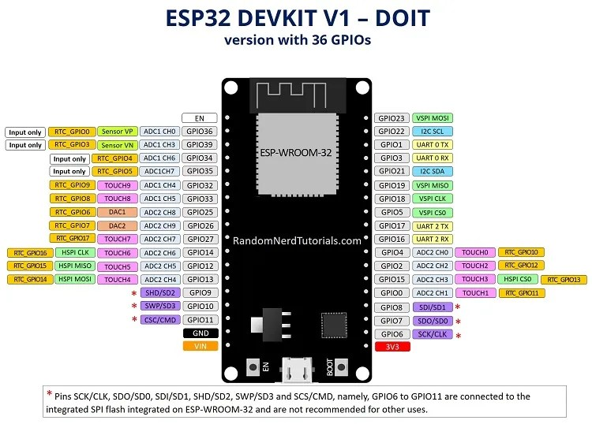](https://i0.wp.com/randomnerdtutorials.com/wp-content/uploads/2018/08/ESP32-DOIT-DEVKIT-V1-Board-Pinout-36-GPIOs-updated.jpg?quality=100&strip=all&ssl=1)

* **Power:**Power is applied through Micro-USB, 3.3V pin, 5V pin, and GND. Regulated 5V is supplied to this pin which is further regulated to 3.3V to power up the board. And 3.3V pin directly supplies the 3.3V regulated to the board. And the ground is connected to GND.
* **Enable:**The enable pin is represented by ‘En’ on the board and is used to reset the microcontroller.
* **Analog Pins:**Analog pins are represented as **ADC1_0 to ADC1_5 and ADC2_0 to ADC2_9**on board. These pins are used to measure the analog voltage in the range from 0-3.3V which is a 12-bit 18 channel ADC.
* **DAC pins:**Two pins **DAC1 and DAC2** are used for digital to analog conversion.
* **I/O Pins:** I/O pins are represented as **GPIO0 to GPIO39** on board which projects there are total of 39 I/O pins on board. All of them can be used as an input or output but pins from 34 to 39 are used for input only.
* **Capacitive Touch Pins:** These pins are represented as **T0 to T9** on board. These are a total of 10 pins which are touch pins that are normally used for capacitive pads.
* **RTC GPIO pins:** These pins are represented as **RTCIO0 to RTCIO17** on board which is a total of 18 pins. These pins are employed to wake up the ESP32 from deep sleep mode.
* **Serial:** Two serial pins are represented on boards as **Tx**and **Rx**. The Tx is used to transmit serial data while Rx is used to receive serial data.
* **External Interrupts:** All **GPIO pins** can be used as external interrupts.
* **PWM:**Any **GPIO pin** can be used as a PWM pin. These GPIO pins are activated through software.
* **VSPI:** These pins are represented as **GPIO23 (MOSI), GPIO19 (MISO), GPIO18 (CLK) and GPIO5 (CS)** which are used for SPI-1 communication.
* **HSPI:** These pins are represented as **GPIO13 (MOSI), GPIO12 (MISO), GPIO14 (CLK) and GPIO15 (CS)** which are used for SPI-2 communication.
* **IIC:** These pins are marked as **GPIO21 (SDA), GPIO22 (SCL)** which are used for I2C communication.
* **AREF:** It is marked as **AREF** which is used to provide a reference voltage for input voltage.

**ESP32 APPLICTIONS**

* Used in Network projects.
* Employed for beginner-level DIY projects.
* Employed in the prototyping of IoT devices.
* Used in cloud-based smart security projects.

Used in low-power battery-operated applications

**GSM**

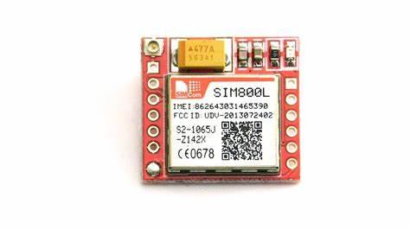

The chip’s operating voltage ranges from 3.4V to 4.4V, making it an ideal candidate for direct LiPo battery supply. This makes it a good option for embedding in projects that are short of space.

All the necessary data pins of the SIM800L GSM chip are broken out to a 0.1″ pitch headers, including the pins required for communication with the microcontroller over the UART. The module supports baud rate from 1200bps to 115200bps with auto-baud detection.

An external antenna is needed for the module to be connected to the network. The module usually comes with a helical antenna that can be soldered onto the module. The board also features a U.FL connector in case you want to keep the antenna away from the board.

There’s a SIM socket on the back! Any 2G Micro SIM card will work perfectly. The correct direction to insert the SIM card is usually engraved on the surface of the SIM socket.

**Features**

This module measures only 1 inch2, but packs a surprising amount of features into its tiny frame. Some of them are listed below:

* Supports Quad-band: GSM850, EGSM900, DCS1800 and PCS1900
* Connect onto any global GSM network with any 2G SIM
* Make and receive voice calls using an external 8Ω speaker & electret microphone
* Send and receive SMS messages
* Send and receive GPRS data (TCP/IP, HTTP, etc.)
* Scan and receive FM radio broadcasts

**Applications :-**

* Remote Data Monitor and Control.
* Water, gas and oil flow metering.
* AMR (automatic meter reading).
* Power station monitoring and control.
* Remote POS (point of sale) terminals.
* Traffic signals monitor and control.
* Fleet management.
* Power distribution network supervision.
* Central heating system supervision.
* Weather station data transmission.
* Hydro-logic data acquisition.
* Vending machine.
* Traffic info guidance.
* Parking meter and Taxi Monitor.
* Telecom equipment supervision (Mobile base station, microwave or optical relay station)

**BUZZER:**

An audio signaling device like a beeper or buzzer may be electromechanical or [piezoelectric](https://www.elprocus.com/what-is-a-piezoelectric-material-working/) or mechanical type. The main function of this is to convert the signal from audio to sound. Generally, it is powered through DC voltage and used in timers, alarm devices, printers, alarms, computers, etc. Based on the various designs, it can generate different sounds like alarm, music, bell & siren.

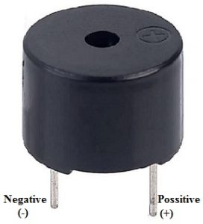

Buzzer Pin Configuration

The **pin configuration of the buzzer** is shown below. It includes two pins namely positive and negative. The positive terminal of this is represented with the ‘+’ symbol or a longer terminal. This terminal is powered through 6Volts whereas the negative terminal is represented with the ‘-‘symbol or short terminal and it is connected to the GND terminal.

The **specifications of the buzzer** include the following.

* Color is black
* The frequency range is 3,300Hz
* Operating Temperature ranges from – 20° C to +60°C
* Operating voltage ranges from 3V to 24V DC
* The sound pressure level is 85dBA or 10cm
* The supply current is below 15mA

**DC motor:**

DC motor is any of a class of rotary electrical motors that converts direct current (DC) electrical energy into mechanical energy. The most common types rely on the forces produced by induced magnetic fields due to flowing current in the coil. Nearly all types of DC motors have some internal mechanism, either electromechanical or electronic, to periodically change the direction of current in part of the motor.

DC motors were the first form of motors widely used, as they could be powered from existing direct-current lighting power distribution systems. A DC motor's speed can be controlled over a wide range, using either a variable supply voltage or by changing the strength of current in its field windings. Small DC motors are used in tools, toys, and appliances. The universal motor, a lightweight brushed motor used for portable power tools and appliances can operate on direct current and alternating current. Larger DC motors are currently used in propulsion of electric vehicles, elevator and hoists, and in drives for steel rolling mills. The advent of power electronics has made replacement of DC motors with AC motors possible in many applications.

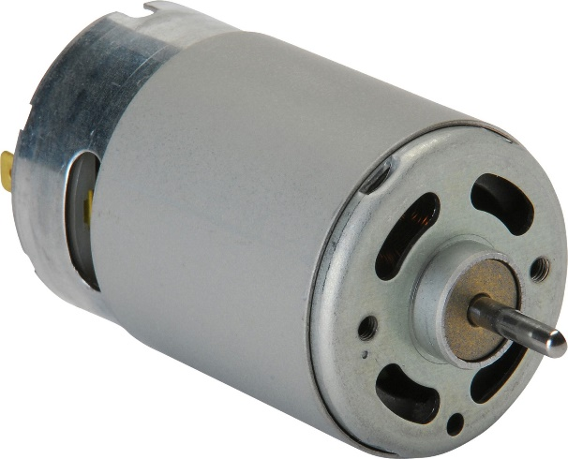

**IGNITION KEY :**

Ignition keys are small metal objects that, when inserted into the keyhole in the ignition of a car, allow the car to start. They come in different shapes and sizes, but all have one purpose — to turn the engine over so it can start.  
  
The keyhole is located on the right side of most cars, just below the steering wheel. Look for it and try to insert the key properly. If it’s not tight enough, you can use a wrench to tighten it up.

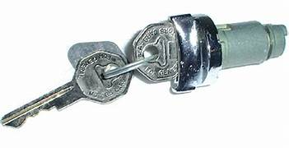

**FINGERPRINT SENSOR:**

The fingerprint sensor is one kind of sensor which is used in a fingerprint detection device. These devices are mainly inbuilt in the fingerprint detection module and it is used for computer safety. The main features of this device mainly include accuracy, better performance, robustness based on exclusive fingerprint [biometric technology](https://www.elprocus.com/biometric-authentication-system-applications/).

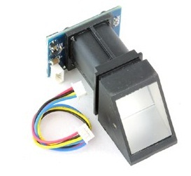

**Features of Fingerprint Sensor**

* It includes image collection as well as chip algorithm
* The fingerprint reader can perform lesser growth and can be fixed into a range of end products
* Power use is low, excellent performance, small in size, and less cost
* [Optical technology](https://www.elprocus.com/optical-sensors-types-basics-and-applications/) which is used is professional, and exact module developed techniques
* The capabilities of[image processing](https://www.elprocus.com/image-processing-projects-for-engineering-students/) are good, and can effectively capture pictures up to 500 dpi resolution

### Fingerprint Sensor Working Principle

The working principle of the fingerprint sensor mainly depends on the processing. The fingerprint processing mainly includes two elements namely enrollment and matching. In fingerprint enrolling, every user requires to place the finger twice.

So that the system will check the finger images to process as well as to generate a pattern of the finger and it will be stored. When matching, a user places the finger using an optical sensor then the system will produce a pattern of the finger & compares it with the finger library templates.

For 1:1 fingerprint matching, the system will evaluate the exits finger with a precise pattern which is selected within the module. Similarly, for 1: N matching, the scanning system will look for the complete finger records for the finger matching. In both situations, the scanning system will go back to the corresponding result, success otherwise crash.

**Specifications**

The specifications of this sensor include the following.

* The fingerprint sensor is an optical type
* The interface is USB1.1/ TTL logical level (UART)
* The speed of scanning is 0.5 sec
* The speed of verification is 0.3 sec
* The capacity storage is 1000
* The security level is 5
* The baud rate of RS232 is 4800BPS ~115200BPS variable
* Current is typical 50 mA, and peak 80mA
* The corresponding technique is 1: N

**MQ3:**

The MQ3 alcohol gas sensor is a module used for detecting alcohol, CH4, benzene, gasoline, hexane, CO, and LPG. It has a sensitive material SnO2 for alcohol gas detection, with lower electrical conductivity in the fresh air. It is a semiconductor alcohol gas sensor that detects or monitors the presence or absence of alcohol. It is also known as **chemiresistors** because sensing of the sensitive material depends on the resistance change when the sensor is exposed to alcohol gas.

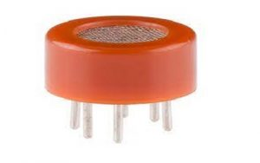

When the sensor is pointed closer to the alcohol gas, the SnO2 conductivity increases. The increase in sensor conductivity is directly proportional to the alcohol concentration. Therefore, the alcohol concentration is measured by any microcontroller very easily. The MQ3 alcohol gas sensor is very fast and has a high sensitivity to alcohol, smoke, and gasoline.  An Alcohol detector can be made using this alcohol sensor.

**Pin Configuration and Structure:**

The **configuration and structure of the MQ3 alcohol sensor** are shown in the figure below. It consists of 2 H-pins for supply and ground connection, 2 A-pins connected to the power supply, and 2 B-pins for output and ground connection. Since A-pins and B-pins can be interchanged.

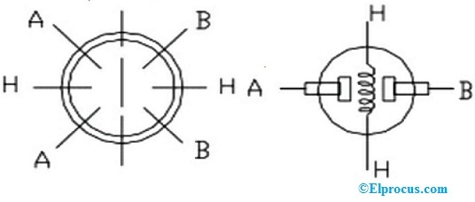MQ3 Sensor Configuration

Inside the MQ3 alcohol gas sensor, the resistance over A and B varies based on the alcohol detection. As the level of alcohol concentration detection increases, the resistance of the sensor decreases.

### MQ3 Alcohol Sensor Module Pin Out/Pin Diagram:

The MQ3 alcohol sensor comes in a 4-pin gas sensor module. The pin configuration/pin diagram is shown in the figure below.

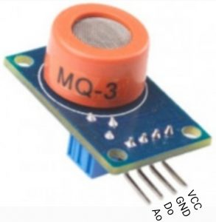

**Pin Configuration of MQ3 Module**

**VCC:** This pin refers to the positive power supply. To power up the sensor, the 5V positive supply is connected to this pin

**GND:** This pin refers to the common ground connection.

**Digital Output (Do):** This pin generates the digital output signal by varying threshold limits with the help of an onboard potentiometer. This pin is to represent the digital output as 0 or 1 based on the alcohol gas present in the air.

**Analog Output (Ao):** This pin generates an analogue output signal in the range of 0V to 5V and it depends on the alcohol gas intensity.

**MQ3 Alcohol Sensor Features:**

#### Technical Specifications:

The MQ3 alcohol sensor technical specifications are listed below.

* It requires a power supply of 5VDC (@ 165mA heater ON / 60mA heater off).
* Consumes 150mA current.
* Digital output Do: 0 and 1 TTL digital (0.1V and 5V).
* Analog output Ao: 0.1V to 0.3V (relates to pollution), voltage concentration is maximum of 4V.
* Alcohol Concentration detection: 0.05 mg/L to 10 mg/L.
* Interface: one TTL compatible input (HSW) and one TTL compatible output (ALR).
* Heater consumes: <750mW.
* Resistance of the heater: 33ohms±5%.

**Relay**

Relays are electric switches that use electromagnetism to convert smallelectrical stimuli into larger currents. These conversions occur when electrical inputs activate electromagnets to either form or break existing circuits Relays can be of different types like electromechanical, [solid state](https://www.electronicshub.org/solid-state-relay/). Electromechanical relays are frequently used. Let us see the internal parts of this relay before knowing about it working. Although many different types of relay were present, their working is same.

Every electromechanical relay consists of an consists of an

1. Electromagnet
2. Mechanically movable contact
3. Switching points and
4. Spring

Electromagnet is constructed by wounding a copper coil on a metal core. The two ends of the coil are connected to two pins of the relay as shown. These two are used as DC supply pins.



Generally two more contacts will be present, called as switching points to connect high ampere load. Another contact called common contact is present in order to connect the switching points.

These contacts are named as normally open (NO),normally closed(NC) and common(COM) contacts.

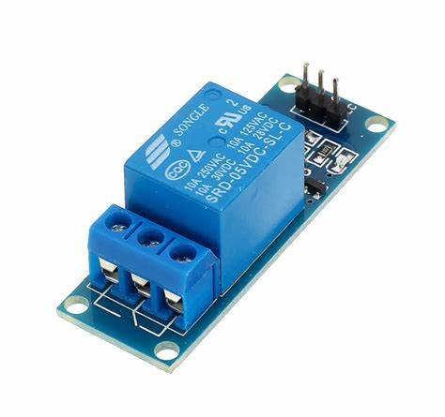

Relay can be operated using either AC or DC.

In case of AC relays, for every current zero position, the relay coil gets demagnetized and hence there would be a chance of continues breaking of the circuit.

So, AC relays are constructed with special mechanism such that continues magnetism is provided in order to avoid above problem. Such mechanisms include electronic circuit arrangement or shaded coil mechanism.

**Working**



* Relay works on the principle of electromagnetic induction.
* When the electromagnet is applied with some current it induces a magnetic field around it.
* Above image shows working of the relay .A switch is used to apply DC current to the load.
* In the relay Copper coil and the iron core acts as electromagnet.
* When the coil is applied with DC current it starts attracting the contact as shown. This is called energizing of relay.
* When the supply is removed it retrieves back to the original position. This is called De energizing of relay.

There are also such relays, whose contacts are initially closed and opened when there is supply i.e. exactly to opposite to the above shown relay.

Solid state relays will have sensing element to sense the input voltage and switches the output using opto-coupling.

**Applications**

* Lighting control systems
* Telecommunication
* Industrial process controllers
* Traffic control
* Motor drives control
* Protection systems of electrical power system
* Computer interfaces
* Automotive
* Home appliances

**SOFTWARE REQUIREMENTS:**

**ARDUINO IDE – 1.8.5**

Arduino is an open-source electronics platform based on easy-to-use hardware and software. Arduino boards are able to read inputs - light on a sensor, a finger on a button, or a Twitter message - and turn it into an output - activating a motor, turning on an LED, publishing something online. You can tell your board what to do by sending a set of instructions to the microcontroller on the board. To do so you use the Arduino programming language (based on Wiring), and the Arduino Software (IDE), based on Processing.

Over the years Arduino has been the brain of thousands of projects, from everyday objects to complex scientific instruments. A worldwide community of makers - students, hobbyists, artists, programmers, and professionals - has gathered around this open-source platform, their contributions have added up to an incredible amount of accessible knowledge that can be of great help to novices and experts alike.

Arduino was born at the Ivrea Interaction Design Institute as an easy tool for fast prototyping, aimed at students without a background in electronics and programming. As soon as it reached a wider community, the Arduino board started changing to adapt to new needs and challenges, differentiating its offer from simple 8-bit boards to products for IoT applications, wearable, 3D printing, and embedded environments. All Arduino boards are completely open-source, empowering users to build them independently and eventually adapt them to their particular needs. The software, too, is open-source, and it is growing through the contributions of users worldwide.

### Why Arduino?

The Arduino software is easy-to-use for beginners, yet flexible enough for advanced users. It runs on Mac, Windows, and Linux. Teachers and students use it to build low cost scientific instruments, to prove chemistry and physics principles, or to get started with programming and robotics. Designers and architects build interactive prototypes, musicians and artists use it for installations and to experiment with new musical instruments. Makers, of course, use it to build many of the projects exhibited at the Maker Faire, for example. Arduino is a key tool to learn new things. Anyone - children, hobbyists, artists, programmers - can start tinkering just following the step by step instructions of a kit, or sharing ideas online with other members of the Arduino community.

There are many other microcontrollers and microcontroller platforms available for physical computing. Parallax Basic Stamp, Netmedia's BX-24, Phidgets, MIT's Handyboard, and many others offer similar functionality. All of these tools take the messy details of microcontroller programming and wrap it up in an easy-to-use package. Arduino also simplifies the process of working with microcontrollers, but it offers some advantage for teachers, students, and interested amateurs over other systems:

* **Inexpensive** - Arduino boards are relatively inexpensive compared to other microcontroller platforms. The least expensive version of the Arduino module can be assembled by hand, and even the pre-assembled Arduino modules cost less than $50
* **Cross-platform** - The Arduino Software (IDE) runs on Windows, Macintosh OSX, and Linux operating systems. Most microcontroller systems are limited to Windows.
* **Simple, clear programming environment** - The Arduino Software (IDE) is easy-to-use for beginners, yet flexible enough for advanced users to take advantage of as well. For teachers, it's conveniently based on the Processing programming environment, so students learning to program in that environment will be familiar with how the Arduino IDE works.
* **Open source and extensible software** - The Arduino software is published as open source tools, available for extension by experienced programmers. The language can be expanded through C++ libraries, and people wanting to understand the technical details can make the leap from Arduino to the AVR C programming language on which it's based. Similarly, you can add AVR-C code directly into your Arduino programs if you want to.
* **Open source and extensible hardware** - The plans of the Arduino boards are published under a Creative Commons license, so experienced circuit designers can make their own version of the module, extending it and improving it. Even relatively inexperienced users can build the breadboard version of the module in order to understand how it works and save money.

**EMBEDDED C:**

Embedded c is a set of language extension for the C Programming language by the C Standards committee to address commonality issues that exist between C extensions for different embedded systems. Historically embedded C programming requires nonstandard extensions to the C language in order to support exotic features such as fixed-point arithmetic, multiple distinct memory banks, and basic I/O operations. Embedded C uses most of the syntax and semantics of standard C, e.g., main() function, variable definition, data type declaration, conditional statements(if, switch, case),loops(while, for),functions, arrays and strings, structures and union, bit operations, macros, etc. During infancy years of microprocessor based systems, programs were developed using assemblers and fused into the EPROMs. There used to be no mechanism to find what the program was doing. LEDs, switches, etc. were used to check for correct execution of the program .But they were too costly and were not quite reliable as well .As time progressed, use of microprocessor-specific assembly-only as the programming language reduced and embedded systems moved onto C as the embedded programming language of choice. C is the most widely used programming language for embedded processors/controllers.

**LITERATURE SURVEY:**

# **[1] Wearable electrochemical alcohol biosensors**

Alan S. Campbell, Kim Jayoung, Wang Joseph

Published in the science direct, August 2018, Pages 126-135.

The rapid development of wearable sensing platforms in recent years has led to an array of viable monitoring applications for various target analytes. As a significant biomarker with high impact in diverse areas, the reliable on-body detection and continuous monitoring of alcohol has become a focus of many such systems. Currently, several commercial sensing platforms are available that are capable of transdermal monitoring of alcohol consumption using insensible sweat. Drawbacks of existing alcohol sensing platforms that apply this sensing strategy have led to efforts in developing wearable biosensors capable of real-time alcohol detection in sampled biofluids such as sensible sweat and skin [interstitial](https://www.sciencedirect.com/topics/engineering/interstitials) fluid. This review discusses the current trends in wearable electrochemical alcohol biosensing and highlights recent advances in such systems toward continuous, real-time monitoring of alcohol consumption. Our perspective on this important field is given with an outlook on the future of wearable electrochemical alcohol biosensors.

# [2] **Design of Multifunctional Bracelet Detecting Alcohol**

[Weibo Wu](https://ieeexplore.ieee.org/author/37087886314); [Zhaoye Li](https://ieeexplore.ieee.org/author/38526252500)

Published in [2019 IEEE 4th Advanced Information Technology, Electronic and Automation Control Conference (IAEAC)](https://ieeexplore.ieee.org/xpl/conhome/8972339/proceeding)

multi-functional alcohol detection bracelet is very useful today. Its circuits are designed and rely on single chip microcomputer. When you are drunk, the alcohol detection module can monitor the alcohol. And the concentration of alcohol value is sent to the LCD liquid crystal display screen in real time. This ability can detect the content of alcohol in human blood. This bracelet is multifunctional, which means both timing and alcohol testing functions.

# [3] **Optoelectonic system for stand-off detection of alcohol vapours**

[Jan Kubicki](https://ieeexplore.ieee.org/author/37086419217); [Jaroslaw Mlynczak](https://ieeexplore.ieee.org/author/37269152400); [Jadwiga Mierczyk](https://ieeexplore.ieee.org/author/37086417796); [Krzysztof Kopczynski](https://ieeexplore.ieee.org/author/37269147400)

**Published in:**[2018 Baltic URSI Symposium (URSI)](https://ieeexplore.ieee.org/xpl/conhome/8401300/proceeding)

The idea of using commercially available cascade lasers for stand-off detection of alcohol vapors in moving cars was presented. Special experimental setup was built to investigate the idea. It was shown, that using cascade lasers, alcohol vapors inside a car can be successfully detected.

# [4] **Portable Alcohol Detection System with Breath-Recognition Function**

[Hironori Wakana](https://ieeexplore.ieee.org/author/37304749900); [Masuyoshi Yamada](https://ieeexplore.ieee.org/author/37086569892); [Minoru Sakairi](https://ieeexplore.ieee.org/author/37992763900)

**Published in:**[2018 IEEE SENSORS](https://ieeexplore.ieee.org/xpl/conhome/8572682/proceeding)

We have developed a portable device that uses a non-contact breath sensor to detect breath-based alcohol. The device's sensor detects saturated water vapor in human breath, and three semiconductor gas sensors detect ethanol, acetaldehyde, and hydrogen. The device can determine whether the gas introduced into it is human breath and the alcohol level at the same time. This ensures that the sample is of a person's breath, not from an artificial source. Alcohol concentration is calculated using an algorithm based on a differential evolution method and each gas sensor's output. The developed device exhibited a measurement accuracy of approximately ±10 ppm by exhaled breath.

# [5] **Embedded Alcohol Sensing Design And Analysis For Air Samples**

[Munaf Ismail](https://ieeexplore.ieee.org/author/37087059699); [Arief Marwanto](https://ieeexplore.ieee.org/author/37395319300); [Jenny Putri Hapsari](https://ieeexplore.ieee.org/author/37089181472); [Muhamad Haddin](https://ieeexplore.ieee.org/author/37086062779)

**Published in:**[2021 8th International Conference on Electrical Engineering, Computer Science and Informatics (EECSI)](https://ieeexplore.ieee.org/xpl/conhome/9624200/proceeding)

WHO through the Global Action Plan on Sustainable Development Goals (SGDs) 2013–2030 provides direction to implement 17 SDGs goals, In this context, WHO targets to reduce alcohol consumption to at least 10% in each country and reduce the number of deaths caused by traffic accidents by as much as 50%. The high death rate from traffic accidents due to the influence of alcohol is a concern for all of us. Excessive alcohol consumption is dangerous when driving because consuming alcohol will affect a person's temperament and worsen driving behavior because it reduces awareness, resulting in accidents. This study designs and analyzes the detection of alcohol levels from a person's breath simulation. A system is needed that is able to detect the alcohol content of vehicle drivers that can be monitored and analyzed, as information to warn motorists of vehicles under the influence of alcohol in order to prevent traffic accidents. Internet of Things (IoT) based alcohol detection system design consists of a series of hardware and software applications in embedded alcohol sensing. The main components consist of the MQ3 sensor to detect the alcohol content of a person's breath and the WeMos D1 mini is the ESP8266 Wi-Fi development board module as an Internet of things (IoT) connection. The tests carried out from the research showed the results of the Blood Alcohol Content (BAC) alcohol content in the test sample by testing several times in a row with the average BAC test results: >0.09, 0.06, 0.03 and 0.00.

# [6] **Alcohol detection for car locking system**

[Shahad Al-Youif](https://ieeexplore.ieee.org/author/37086418519); [Musab A. M. Ali](https://ieeexplore.ieee.org/author/37986246200); [M. N. Mohammed](https://ieeexplore.ieee.org/author/37086419944)

**Published in:**[2018 IEEE Symposium on Computer Applications & Industrial Electronics (ISCAIE)](https://ieeexplore.ieee.org/xpl/conhome/8399564/proceeding)

In this prototyped project, an attempt will be made to develop a locking system for cars so it would not start without alcohol checking mechanism. The system will take the advantage of a pre-existing Alcohol sensor. In fact, the project is intended for granting a base start for further explorations in the future. This project aimed at the exiting efforts of accidents prevention system developments, in hope of implementing it in the real life to increase roads safety.

**REFERENCE:**

[1] N. H. T. S. Administration, "Traffic Safety Facts 2014," AlcoholImpaired Driving, pp. 1-7, December 2015.

[2] I. T. S. D. a. A. Group and I. T. Forum, "IRTAD road safety annual report 2015," Organisation for Economic Co-operation and Develop, 2015.

[3] "Arduino - ArduinoBoardUno," [Online]. Available: https://www.arduino.cc/en/Main/ArduinoBoardUno. [Accessed 2016].

[4] J. Lavanya and R. E. Raj, "A Mobile Based Novice Detection of Driver’s Fatigue Level and Accident Reporting Solution," Power Electronics and Renewable Energy Systems Proceedings of ICPERES 2014, vol. 326, pp. 883-892, 2015.

[5] L. HANWEI ELETRONICS CO., "MQ-3 Gas Sensor Datasheet," [Online]. Available: https://www.sparkfun.com/datasheets/Sensors/MQ3.pdf. [Accessed 2016].

[6] L. Ada, "Adafruit Motor Shield," Adafruit Industries, 7 June 2015. [Online]. Available: https://cdnlearn.adafruit.com/downloads/pdf/adafruit-motor-shield.pdf. [Accessed 2016].

[7] http://electrical4u.com/.